25SC1306E – COMPUTATIONAL FOUNDATION FOR ARTIFICIAL INTELLIGENCE

PROJECT REPORT ON

8-PUZZLE SOLVER AND VISUALIZER

USING ARTIFICIAL INTELLIGENCE SEARCH ALGORITHMS

Under the Guidance of
DR. CH. SANDEEP REDDY

Roll No. | Student Name
2510030157 | Vaishnavi Mourya
2510030193 | Kande Venkata Sai Abinaya
KONERU LAKSHMAIAH EDUCATION FOUNDATION
Department of Artificial Intelligence
June – 2026
18- 06- 2026
CERTIFICATE
This is to certify that the project entitled “8-Puzzle Solver and Visualizer Using Artificial Intelligence Search Algorithms” submitted by Vaishnavi Mourya (2510030157) and Abinaya (2510030193) is a bonafide record of work carried out under the guidance of Dr. Ch. Sandeep Reddy, Department of Artificial Intelligence, in partial fulfillment of the requirements for the course Computational Foundation for Artificial Intelligence (25SC1306E) during the academic year
2025–26.

ACKNOWLEDGEMENT
We express our sincere gratitude to Dr. Ch. Sandeep Reddy, Department of Artificial Intelligence, for his valuable guidance, encouragement, and continuous support throughout the project.
We thank the Department of Artificial Intelligence and KLEF for providing resources and facilities required for the successful completion of this project.
We also thank our friends and family members for their motivation and support.

ABSTRACT
The 8-Puzzle Solver and Visualizer is an Artificial Intelligence-based web application developed to solve the classical 8-puzzle problem using multiple search algorithms. The system implements Breadth First Search (BFS), Depth First Search (DFS), Uniform Cost Search (UCS), Greedy Best First Search, and A* Search algorithms.
The application provides an interactive environment where users can enter puzzle configurations, select algorithms, and visualize the search process step-by-step. Heuristic functions such as Manhattan Distance and Misplaced Tiles are incorporated to improve search efficiency.
The project also provides performance comparisons based on execution time, nodes explored, and solution optimality. Experimental results demonstrate that A* Search with Manhattan Distance heuristic provides the most efficient solution

INTRODUCTION
Artificial Intelligence (AI) is a branch of computer science concerned with developing intelligent systems capable of solving complex problems. Search algorithms form the foundation of many AI applications because they allow computers to systematically explore possible solutions.
The 8-puzzle problem is a classic AI problem consisting of eight numbered tiles and one blank space arranged on a 3×3 board. The objective is to rearrange the tiles into a predefined goal configuration by sliding tiles into the empty space.
This project demonstrates how various AI search algorithms can be applied to solve the puzzle efficiently while providing visual representations of the search process.

PROBLEM STATEMENT
The 8-puzzle problem requires transforming an initial arrangement of tiles into a goal configuration through a sequence of valid tile movements.
As the number of possible states increases, manually identifying the optimal solution becomes difficult. Therefore, intelligent search techniques are required to efficiently explore the state space and generate solutions.
The objective of this project is to develop an interactive visualization system that demonstrates how different search algorithms solve the puzzle and compares their performance.

OBJECTIVES
- Develop an interactive 8-puzzle visualizer.
- Implement BFS algorithm.
- Implement DFS algorithm.
- Implement UCS algorithm.
- Implement Greedy Best First Search.
- Implement A* Search algorithm.
- Implement Manhattan Distance heuristic.
- Implement Misplaced Tiles heuristic.
- Visualize solution steps.
- Compare algorithm performance.
- Enhance understanding of AI search techniques.

LITERATURE SURVEY
The 8-puzzle problem has been widely used as a benchmark problem in Artificial Intelligence research.
Breadth First Search guarantees optimal solutions but requires significant memory. Depth First Search uses less memory but may not find optimal solutions.
Uniform Cost Search expands nodes according to path cost and guarantees optimality. Greedy Best First Search uses heuristic information to guide the search process.
A* Search combines actual path cost and heuristic cost, making it one of the most efficient search techniques for solving state-space problems.

STATE SPACE REPRESENTATION
The 8-puzzle problem can be represented as a state-space graph.
Each puzzle configuration represents a state, and every valid tile movement creates a transition to a new state.
Goal State
1 2 3
4 5 6
7 8 _
The search algorithms explore different states until the goal state is reached.
SYSTEM ARCHITECTURE
User Input
|
Puzzle Board
|
Algorithm Selection
|
Search Engine
|
Heuristic Module
|
Solution Generator
|
Visualizer
|
Statistics Panel
The architecture consists of user interaction, search processing, heuristic evaluation, solution generation, and visualization modules.
BREADTH FIRST SEARCH
Breadth First Search explores nodes level by level.
Steps
- Insert start state into queue.
- Remove first state.
- Check goal condition.
- Generate successor states.
- Add unexplored states to queue.
- Repeat until goal state is found.
Advantages
- Complete
- Optimal
Disadvantages
- High memory consumption

DEPTH FIRST SEARCH
Depth First Search explores deeper states before exploring sibling states.
Steps
- Push initial state onto stack.
- Pop top state.
- Generate successors.
- Push successors onto stack.
- Continue until goal state.
Advantages
- Low memory usage
Disadvantages
- Not optimal

UNIFORM COST SEARCH
Uniform Cost Search expands nodes based on path cost.
Features
- Uses priority queue.
- Expands lowest-cost node first.
- Guarantees optimal solutions.
Advantages
- Optimal
Disadvantages
- Higher computational requirements

GREEDY SEARCH
Greedy Search selects nodes with minimum heuristic value.
Formula
f(n) = h(n)
Advantages
- Fast execution
Disadvantages
- Does not guarantee optimal solution

A* SEARCH ALGORITHM
A* Search combines path cost and heuristic cost.
Formula
f(n) = g(n) + h(n)
Where:
- g(n) = actual path cost
- h(n) = heuristic estimate
A* is considered one of the most efficient AI search algorithms.

MANHATTAN DISTANCE
The Manhattan Distance heuristic calculates the total distance of each tile from its goal position.
Formula
h(n) = Σ(|x₁ − x₂| + |y₁ − y₂|)
Benefits
- More informative heuristic
- Faster search convergence
- Produces optimal solutions with A*

MISPLACED TILES
This heuristic counts the number of tiles that are not in their correct positions.
Formula
h(n) = Number of Misplaced Tiles
Benefits
- Easy implementation
- Faster than uninformed search
Limitation
- Less accurate than Manhattan Distance

IMPLEMENTATION DETAILS
Technologies Used
- React.js
- Vite
- JavaScript
- CSS
Features
- Interactive puzzle board
- Step-by-step visualization
- Solution animation
- Performance metrics
- Algorithm comparison dashboard

Source Code Repository
The complete source code for the project is maintained on GitHub.
Repository Link:

https://github.com/vaishnaviM-ui/8-puzzle-solver

The repository contains:
- React frontend source code
- Search algorithm implementations
- Heuristic functions
- Project documentation
- Deployment configuration
RESULTS AND ANALYSIS:

Algorithm | Optimal | Speed
BFS | Yes | Medium
DFS | No | Fast
UCS | Yes | Medium
Greedy | No | Fast
A* Manhattan | Yes | Very Fast
A* Misplaced | Yes | Fast

Home Page:
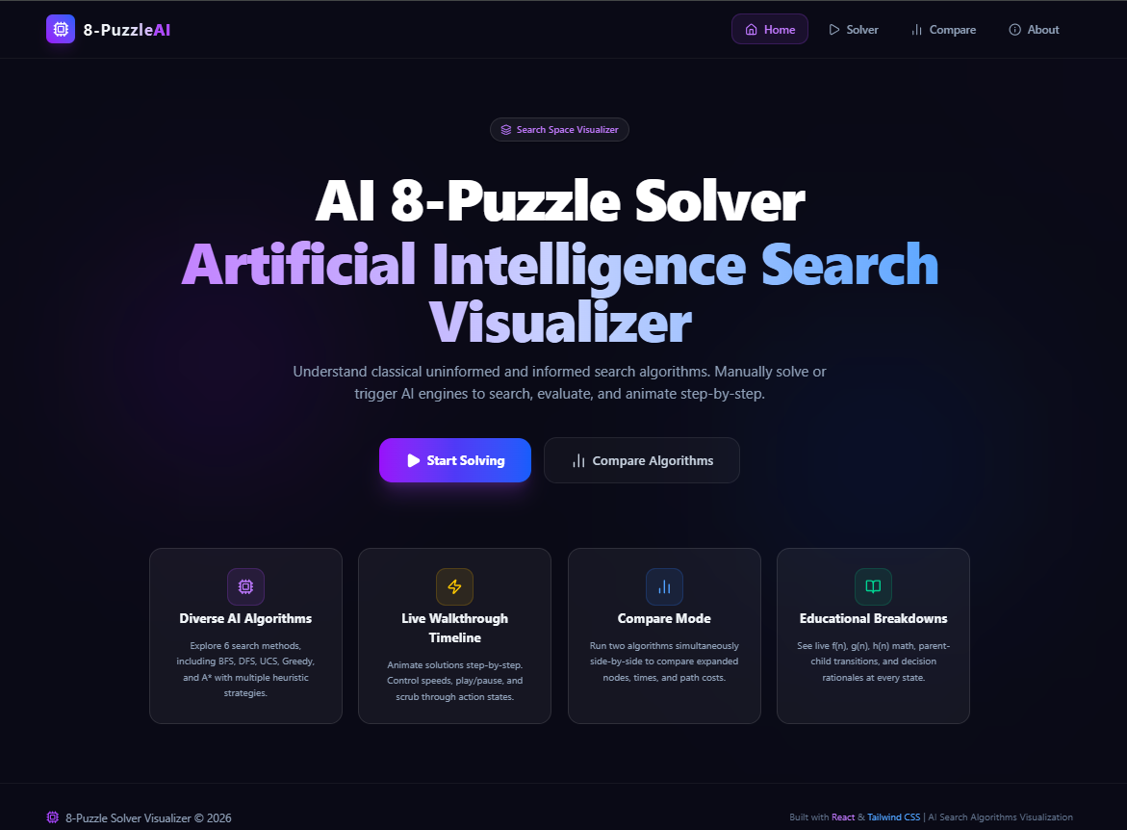

Puzzle Board
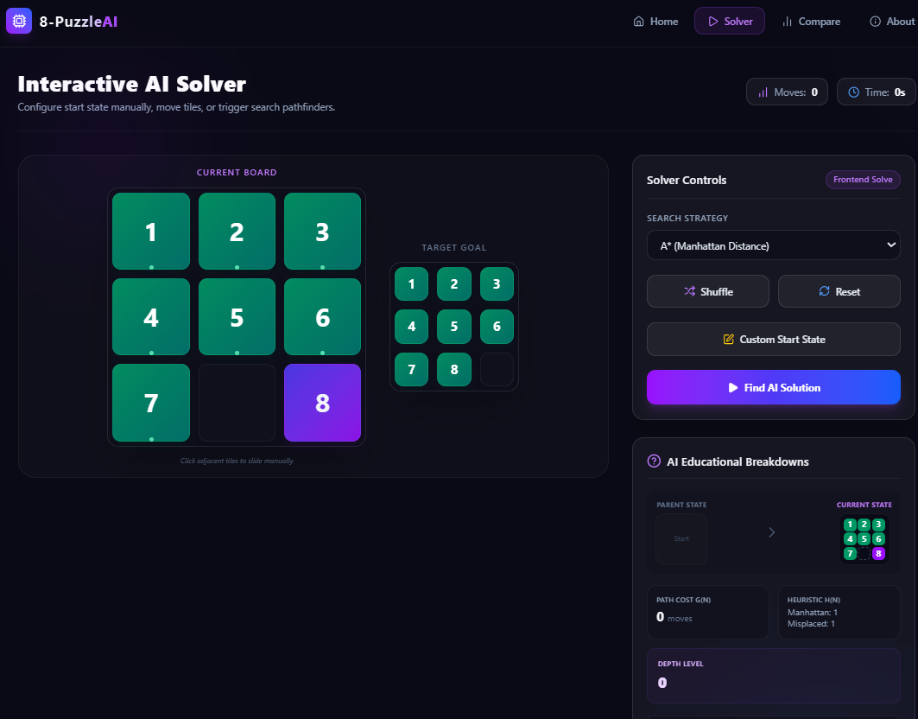

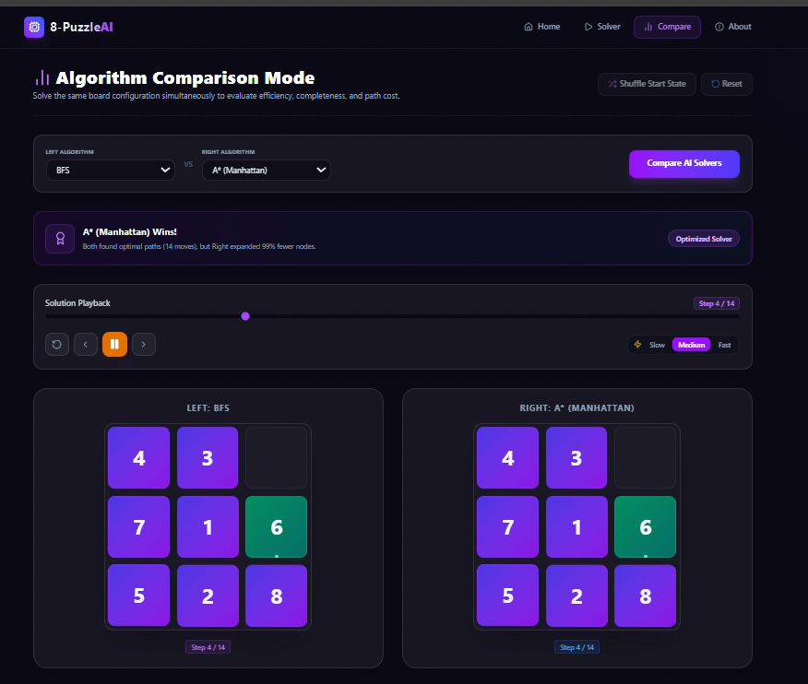
Before and after Comparing the algorithm
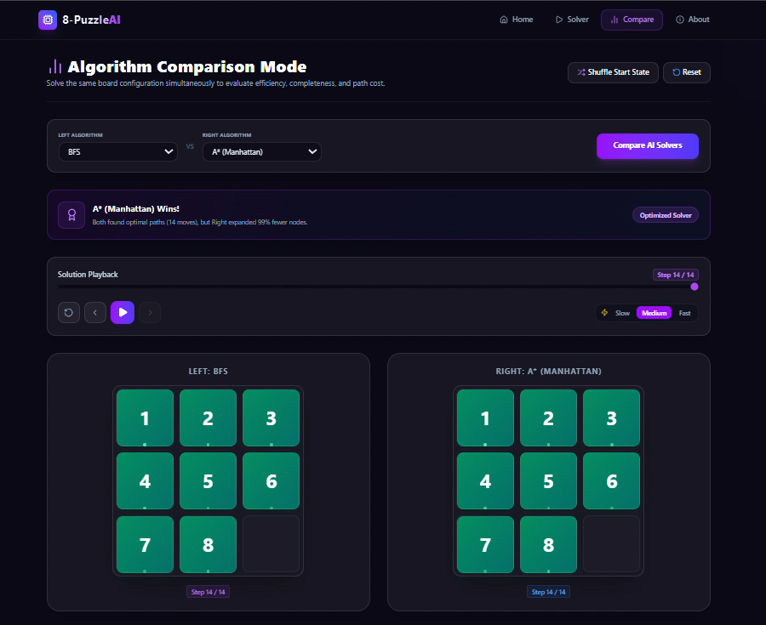

TEAM CONTRIBUTION:

Student | Contribution
Vaishnavi Mourya  2510030157 | Requirement Analysis, BFS, DFS, UI Design, Testing, Documentation, Presentation
K.V.Sai Abinaya  2510030193 | UCS, Greedy Search, A*, Heuristics, Performance Analysis

CONCLUSION:
The project successfully demonstrates the application of Artificial Intelligence search techniques to solve the 8-puzzle problem. Multiple algorithms were implemented and compared based on performance metrics.
The experimental results indicate that A* Search combined with Manhattan Distance heuristic provides the most efficient and optimal solution. The project serves as a valuable educational tool for understanding state-space search algorithms.

FUTURE SCOPE
- Support 15-puzzle and larger puzzles.
- Add additional heuristic functions.
- Implement Bidirectional Search.
- Add Machine Learning based search strategies.
- Improve visualization and analytics.
- Deploy as a full educational web platform.

REFERENCES
- Stuart Russell and Peter Norvig, Artificial Intelligence: A Modern Approach.
- Elaine Rich and Kevin Knight, Artificial Intelligence.
- React Documentation.
- Vite Documentation.
- AI Search Algorithm Research Papers.
- Course Material – Computational Foundation for Artificial Intelligence.
- Online Educational Resources on State Space Search.

Thank You !

